APPLE IOS Workaround

Create a New Apple ID
1. Go into your App store, tap human icon at the top right corner and sign out of your existing ID.
2. To create your new Apple ID, you can follow the link: https://appleid.apple.com/#!&page=signin. Fill in all the required fields. And select the new country, from where your desired app belongs to. Tap Continue. With this, you’ll receive a verification code via email. Enter the code on your device, and your new Apple ID will automatically be created.

3. Then search for the App you want to download on App Store. Once you click on to install button. A message will appear where you have to sign in again with your new Apple ID.
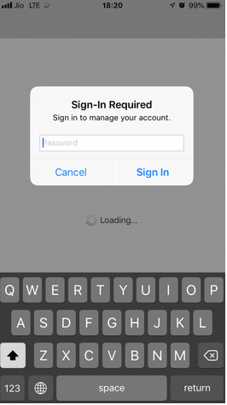
4. Enter specific details about account billing information. Enter Apple ID, Select mode of payment to “None”, fill out the Irish Billing Address, contact information and click “Next” to proceed. In your new ID, don’t add your credit card information.
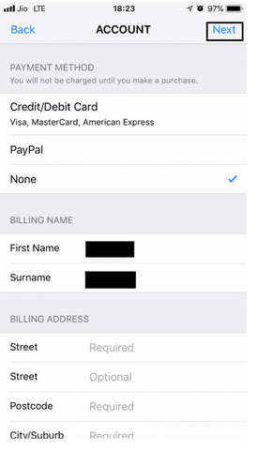
5. Now your device is all set to fix this app is not available in your country or region. And you can download any App as you want.

